Artificial Intelligence & Machine Learning Development

EMOTION DETECTION & LEARNING SUPPORT ENGINE
An AI-Driven Web Application for Emotion-Aware Personalized Learning Support

BACHELOR OF TECHNOLOGY
In
COMPUTER SCIENCE AND ENGINEERING

Submitted by

MALAKALA VENAKTESWARARAO (TEAM LEAD)
SAMIDALA SATYA MAHALAKSHMI APARNA
GAYATHRI PRIYA PALURI
HEMANTH MAMIDI
BHARATH KUMAR

ACKNOWLEDGEMENT
We express our sincere gratitude to APSCHE-SMARTBRIDGE for providing us with the opportunity to undertake the AI/ML development project titled EMOTION DETECTION & LEARNING SUPPORT ENGINE.
This project enabled us to gain practical experience in designing, training, and deploying an emotion-aware AI system. Throughout the project, we enhanced our understanding of deep learning architectures (BiLSTM, BERT), prompt engineering with generative AI, Streamlit application development, and end-to-end model deployment.
We are also thankful to our faculty members and everyone who directly or indirectly contributed by offering suggestions, encouragement, and constructive feedback during the development process.
Finally, we thank our team members for their dedication, cooperation, and commitment, which made the successful completion of this project possible.

ABSTRACT
The Emotion Detection & Learning Support Engine is an AI-driven web application that transforms a learner's free-text description of a study challenge into an emotion-aware, supportive response. The system combines deep learning emotion classifiers — BiLSTM and BERT — with rule-based keyword enhancement and Gemini-generated guidance to predict nuanced emotional states such as Bored, Confident, Curious, Confused, and Frustrated.
The platform ingests raw student or learner input, classifies the primary and any secondary (mixed) emotions along with a confidence score, and delivers tailored next steps, tips, and encouragement within seconds. Dual-model comparison between BiLSTM and BERT improves reliability and transparency, allowing users to verify consistency across emotional predictions.
Beyond prediction, the system logs every interaction to CSV for continuous learning and analytics, visualizes emotion trends, and supports response regeneration when the learner's input changes. The frontend is built with Streamlit for a fast, interactive experience, while PyTorch-based models and the Gemini API power the emotion classification and guidance-generation pipeline respectively.
The application demonstrates modern applied AI development practices, including dual-model NLP classification, prompt engineering, responsible AI considerations, and cloud deployment via Vercel. The Emotion Detection & Learning Support Engine aims to reduce manual effort in interpreting learner sentiment, speed up response cycles for educators and TAs, and give self-study learners fast, empathetic guidance.

1. Introduction
Introducing the Emotion Detection & Learning Support Engine — an empathy-first AI companion for every study challenge. Educators, teaching assistants, and academic support teams often spend significant time manually reading student messages, guessing emotions, and crafting an appropriately supportive tone before responding. This slows down response cycles and can cause struggling students to be missed.
At the same time, learners studying independently frequently need quick, empathetic guidance when they get stuck, but searching forums or drafting help requests takes time and rarely captures how they actually feel. The Emotion Detection & Learning Support Engine removes these bottlenecks by automatically classifying the emotion behind a learner's text, surfacing a confidence level, and generating a supportive, field-specific reply — turning manual sentiment interpretation into a fast, transparent, AI-assisted workflow.

2. Project Overview

Purpose
The Emotion Detection & Learning Support Engine is developed to provide a fast, transparent, and empathetic AI platform that reads a learner's free-text description of a study problem and responds with an emotion-aware, actionable message. The project aims to remove the friction and delay from manually interpreting learner sentiment by combining two independently trained deep learning classifiers (BiLSTM and BERT) with Gemini-powered natural language guidance. Built using Python, PyTorch, and Streamlit, the application allows learners and educators alike to instantly see the detected emotion, compare model predictions, and receive tailored next steps and encouragement.

Features
The Emotion Detection & Learning Support Engine provides the following key features:
- Emotion-Aware Text Analysis: Classifies a learner's free-text input into one of five emotional states — Bored, Confident, Curious, Confused, or Frustrated.
- Mixed-Emotion Detection: Surfaces secondary emotions whenever they cross a defined confidence threshold (≥15%), giving a more nuanced emotional picture than a single label.
- Dual-Model Comparison: Runs both a BiLSTM classifier and a fine-tuned BERT classifier side-by-side, so predictions can be cross-verified for consistency.
- Confidence Scoring: Every prediction is returned with a numeric confidence score to indicate how certain the model is.
- AI-Powered Guidance Generation: Uses the Gemini API to turn the detected emotion and field/problem context into an empathetic, professionally-worded support response.
- Personalized Strategies: Generates a bulleted set of concrete, actionable next steps tailored to the learner's stated problem and detected emotional state.
- Response Regeneration: Automatically regenerates the AI response whenever the learner's input changes, keeping guidance fresh and relevant.
- Session History & CSV Logging: Persists every interaction to CSV for record-keeping, auditing, and downstream analytics.
- Interactive Streamlit UI: A responsive, session-state-driven interface with clear sections for field/problem input, run/clear controls, and loading indicators.
- Emotion Trend Visualization: Visualizes scores and prediction trends using Plotly charts within the app.
- Cached Model Loading: Loads BiLSTM and BERT models once and caches them for fast, repeated inference.
- Cloud Deployment: Deployed as a live web application (Vercel) so learners and educators can access it directly from a browser.

Future Enhancements
- Support for additional languages and multilingual emotion detection.
- A dedicated analytics dashboard for instructors to view aggregated emotion trends across a cohort.
- Integration with LMS platforms (e.g. Google Classroom, Moodle) for in-context learner support.
- Voice-based input for hands-free emotion analysis.

3. Architecture
- Frontend: The UI layer is implemented in Streamlit, providing a responsive, session-state-driven interface for entering a learner's challenge, triggering analysis, and viewing results (detected emotion, model comparison, support response, and personalized strategies).
- Emotion Detection Pipeline: Raw learner text is preprocessed and keyword-enhanced, then passed through two independently trained classifiers — a BiLSTM model (5-class softmax) and a fine-tuned BERT model with class weighting — producing a unified prediction schema with primary emotion, mixed emotions, and confidence score.
- Guidance & Regeneration Engine: The detected emotion, field, and problem text are used to build a prompt for the Gemini API, which generates an empathetic, field-aware support response and a set of personalized strategies. Responses are automatically regenerated when the learner's input changes.
- Persistence: Session history and every analyzed interaction are logged to CSV for continuous learning, auditing, and analytics; trained models are cached after first load for fast subsequent inference.
- Deployment: The application is deployed as a live web app on Vercel, with model training performed separately on Kaggle (GPU-backed) before being exported and integrated locally.

4. Setup Instructions

Prerequisites
Before configuring the Emotion Detection & Learning Support Engine, ensure the following exist in your development environment:

Hardware Requirements
- Processor: Intel i3 or above
- RAM: Minimum 4 GB, recommended 8 GB
- Storage: Minimum 2 GB free disk space
- Internet Connection: Required for dataset download, package installation, and cloud deployment
- Display: Standard monitor with web browser support

Software Requirements
- Python (latest stable version, 3.9+)
- pip (Python Package Manager)
- Git
- A Kaggle account (GPU runtime, for model training)
- A Gemini API key
- Visual Studio Code (or any preferred IDE)

Key Dependencies
- Streamlit — interactive web application framework
- PyTorch — deep learning framework for BiLSTM and BERT models
- Transformers — for the BERT classifier
- NumPy — numerical computing
- Plotly — score and trend visualization
- Gemini AI (google-generativeai) — guidance generation
- python-dotenv — environment variable management

Installation Steps
1. Clone the repository:
git clone https://github.com/venkateshmalakala/Emotion-Detection-Learning-Support-Engine.git
2. Step inside the project's code folder:
cd Emotion-Detection-Learning-Support-Engine/code
3. Create and activate a virtual environment:
python -m venv venv
venv\Scripts\activate (Windows)
source venv/bin/activate (macOS/Linux)
4. Install project dependencies:
pip install -r requirements.txt
5. Create environment variable parameters (.env in /code):
GEMINI_API_KEY=your_gemini_api_key
6. Verify that the trained model and data directories are present before launching the app.

5. Folder Structure

Repository Structure
Emotion-Detection-Learning-Support-Engine/
code/
├── api/
├── src/
├── tests/
├── .gitignore
├── README.md
├── app.py
├── requirements.txt
├── streamlit_app.py
└── vercel.json
- api/ — Serverless/API entry points used for deployment integration
- src/ — Core application source: preprocessing, model loading, and guidance-generation logic
- tests/ — Automated tests validating the emotion detection and guidance pipeline
- app.py — Main application entry point
- streamlit_app.py — Streamlit UI definition and session-state handling
- requirements.txt — Python dependency list
- vercel.json — Deployment configuration for Vercel

6. Running the Application
Step 1: Navigate to the code directory:
cd Emotion-Detection-Learning-Support-Engine/code
Step 2: Install dependencies (if not already installed):
pip install -r requirements.txt
Step 3: Start the Streamlit application:
streamlit run streamlit_app.py
Step 4: The application will run on:
http://localhost:8501
or access the live deployed version at:
https://emotion-detection-learning-support.vercel.app/

7. Core Modules & Processing Pipeline
- Text Preprocessing & Keyword Enhancement — Cleans and normalizes learner input and applies rule-based keyword enhancement (Registered Devotee equivalent: any user) before classification.
- BiLSTM Classifier (5-Class Softmax) — Predicts the primary emotion from a fixed set of five classes.
- BERT Classifier with Class Weighting — A fine-tuned transformer model providing a second, independent prediction to cross-verify the BiLSTM output.
- Mixed-Emotion Detection — Flags secondary emotions whenever their score crosses a ≥15% threshold relative to the primary emotion.
- Unified Prediction Schema — Combines both model outputs, the mixed-emotion list, and the confidence score into a single response object consumed by the UI.
- Guidance Generation — Builds a Gemini prompt from the field, problem text, and detected emotion, then returns an empathetic support response and personalized strategies.
- Session & CSV Logging — Persists each interaction (input, predictions, and generated guidance) to CSV and maintains in-session history for the Streamlit UI.

8. Testing
Testing was conducted to verify that all modules of the Emotion Detection & Learning Support Engine function correctly and meet the specified requirements. The application was tested across all five emotion classes to confirm classification accuracy, and mixed-emotion detection was validated against the defined confidence threshold.
Model comparison testing confirmed that BiLSTM and BERT predictions could be reliably cross-checked for consistency. Integration testing ensured smooth communication between the Streamlit frontend, the emotion detection pipeline, and the Gemini-based guidance engine. The full UI flow — from entering a learner's challenge through to viewing the detected emotion, model comparison, support response, and personalized strategies — was validated end-to-end, and the application was assessed for deployment readiness and optimization before going live on Vercel.

9. Project Flow
Project demo and repository:
GitHub: https://github.com/venkateshmalakala/Emotion-Detection-Learning-Support-Engine
Live App: https://emotion-detection-learning-support.vercel.app/

Milestone 1: Environment Setup and Dependency Configuration
- Obtain Gemini API Key
- Install Python & create a virtual environment
- Install project dependencies
- Create the .env configuration file
- Verify model and data directories
- Prepare the project folder structure

Milestone 2: Kaggle Model Training and Integration
- Kaggle setup (GPU + dependencies)
- Data preprocessing & tokenization
- BiLSTM model training
- Domain-adaptive fine-tuning
- BERT model fine-tuning
- Model export & local integration

Milestone 3: Core Emotion Detection Pipeline Development
- Text preprocessing & keyword enhancement
- BiLSTM classifier (5-class softmax)
- BERT classifier with class weighting
- Mixed-emotion detection (≥15% secondary threshold)
- Unified prediction schema
- CSV persistence & cached model loading

Milestone 4: AI-Powered Guidance & Regeneration Engine
- Capture field + problem, build Gemini prompt
- Generate empathetic, field-aware responses
- Regenerate responses when input changes
- Maintain session history and CSV logging

Milestone 5: Streamlit UI Implementation
- Responsive layout with session state
- Sections for field selection & problem input
- Form controls — run/clear, spinners
- Visualize scores using Plotly charts

Milestone 6: User Interaction & Deployment Readiness
- Validate UI flow end-to-end
- Optimization and deployment readiness

Conclusion
The Emotion Detection & Learning Support Engine successfully demonstrates how dual-model deep learning classification (BiLSTM and BERT) can be combined with generative AI (Gemini) to deliver fast, empathetic, and actionable support to learners and educators. The completed system reduces manual effort in interpreting learner sentiment, maintains consistent and transparent emotional predictions through model comparison, and provides a smooth, deployable Streamlit experience accessible from any browser.

10. Project Implementation Steps
• Landing Page & Challenge Input: The empathy-first landing page introduces the platform's core capabilities — mixed-emotion detection, model comparison, and real-time suggestions — and provides the "Enter the learner's challenge" input box where users describe their study problem before clicking "Analyze emotions".
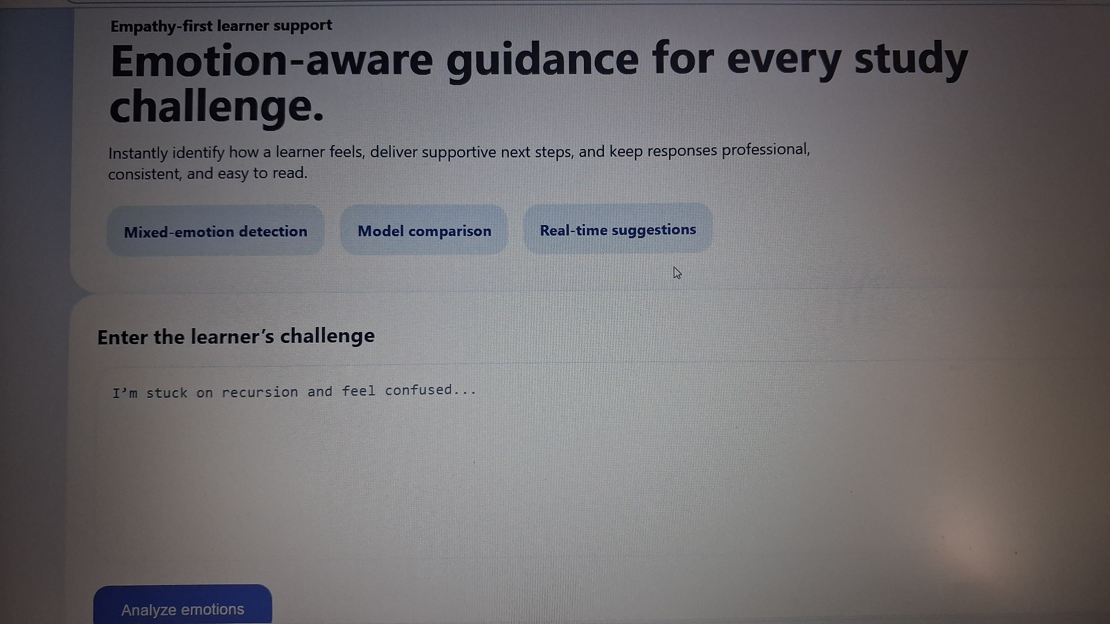
Landing page and learner challenge input
• Emotion Analysis Results: Once a challenge is submitted, the platform displays the detected primary and mixed emotions with a confidence score, a side-by-side BiLSTM vs. BERT model comparison, an empathetic support response, and a bulleted list of personalized strategies.
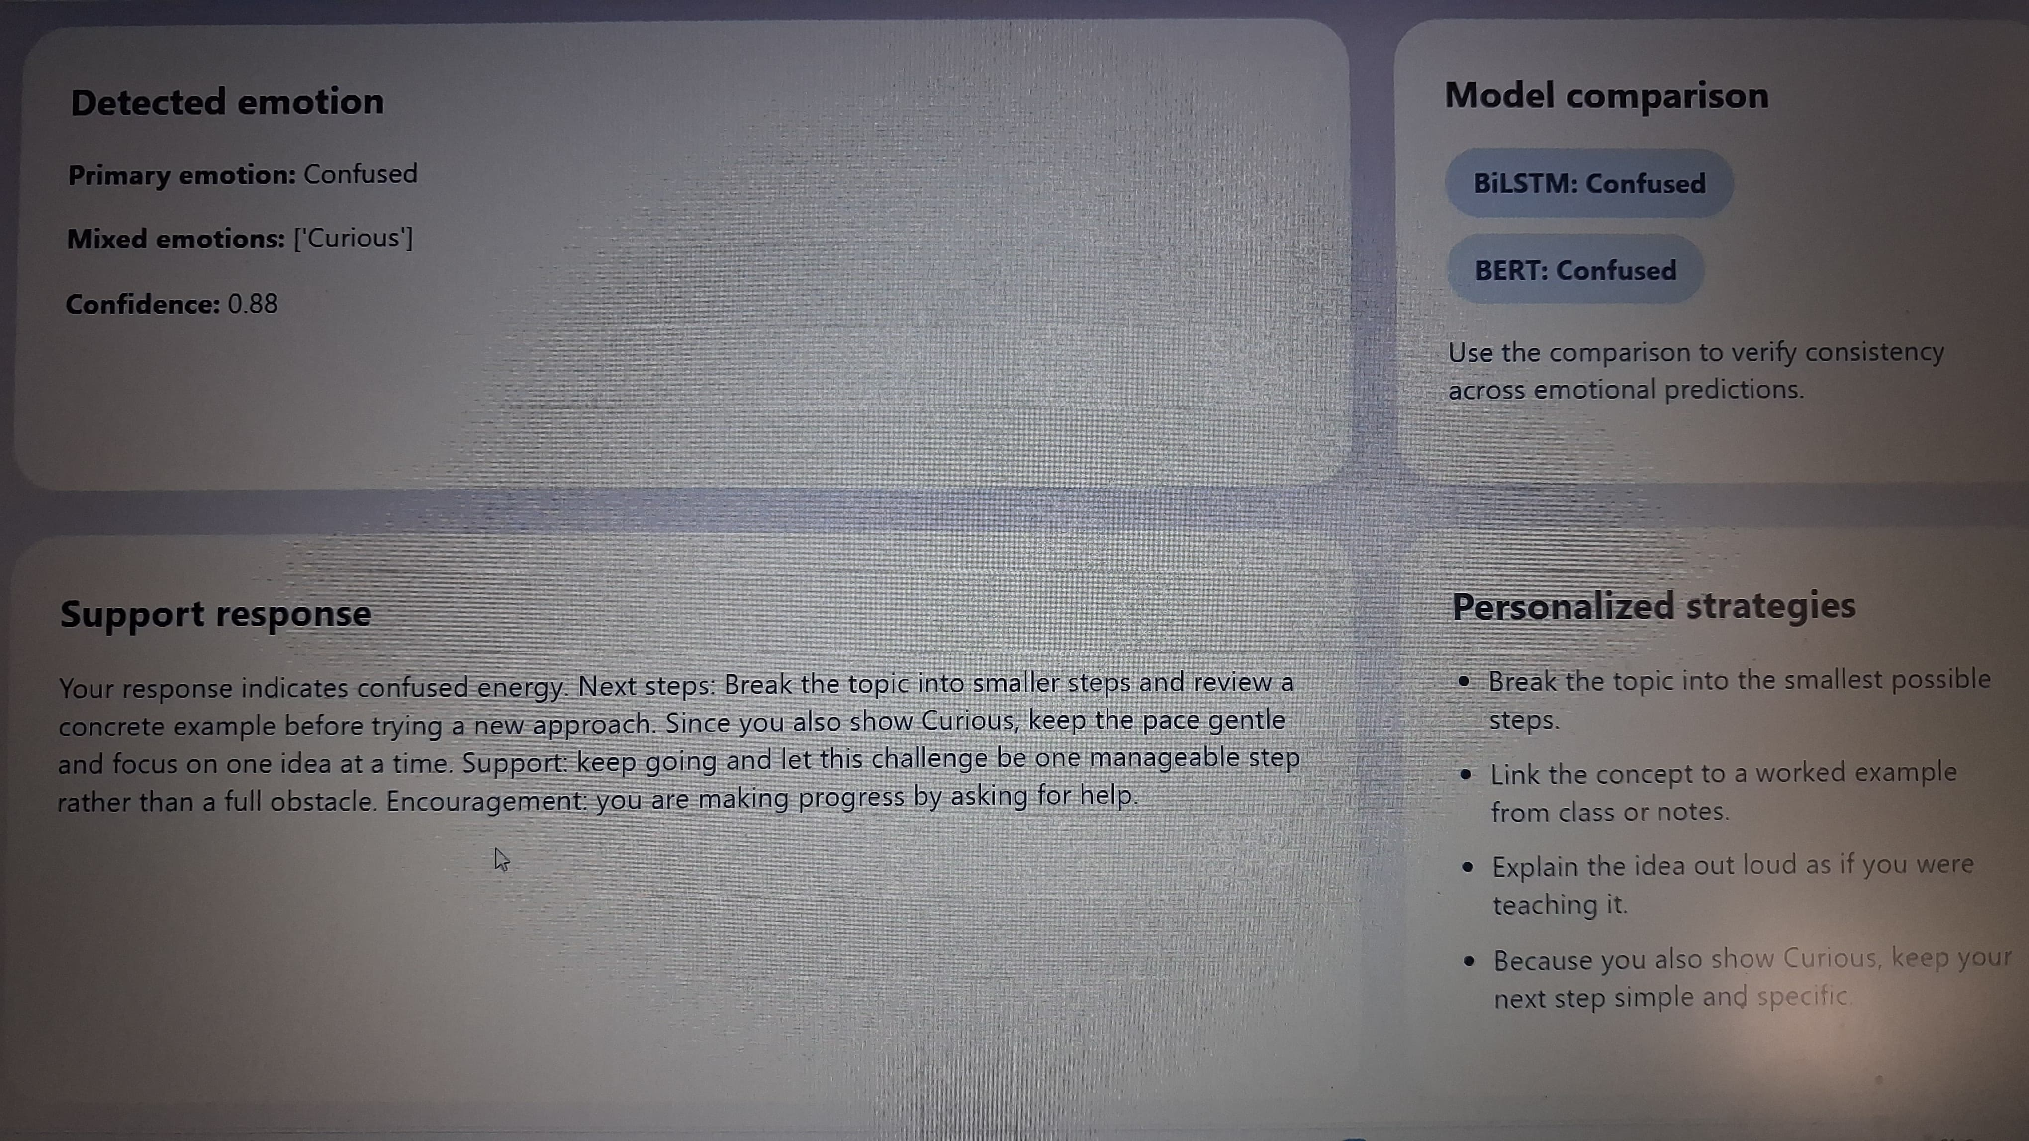
Emotion analysis results: detected emotion, model comparison, support response, and personalized strategies

